The software architecture of a program or computing system is the structure or structures of the system, which comprise software elements, the externally visible properties of those elements, and the relationships among them.

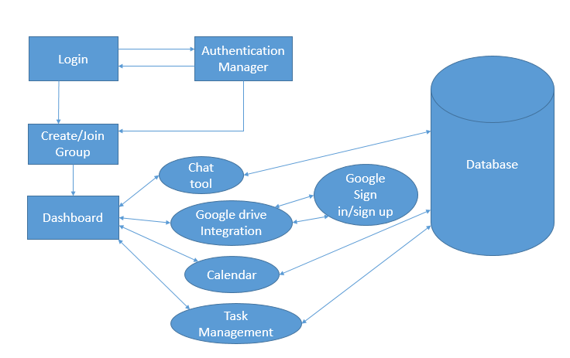

The above software architecture is based on our project management plan project, when the user enters the credential’s they are logged in and once the user logs into the page then he/she can create/join the group and now he/she can view his dashboard where they are few tasks like chat tool, google drive integration, calendar events, task management and there the functionality goes with that tasks. For editing, uploading, or viewing the documents then they can be redirected to the sign in the google. All the tasks are now connected to database to backup and to retrieve the data.